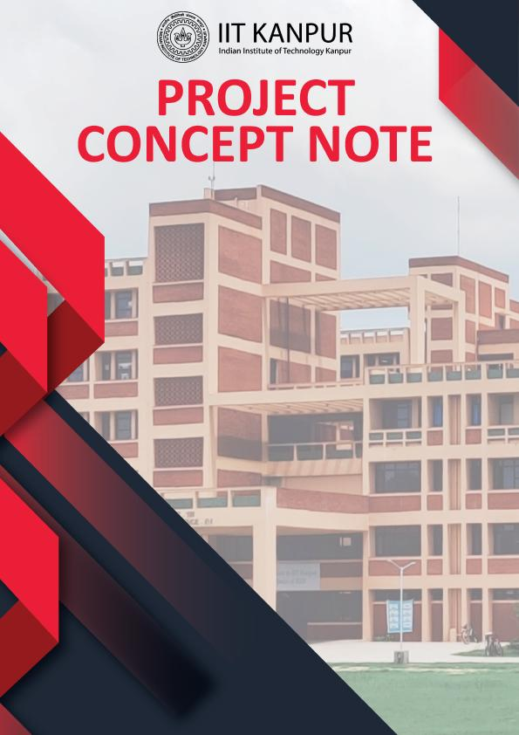

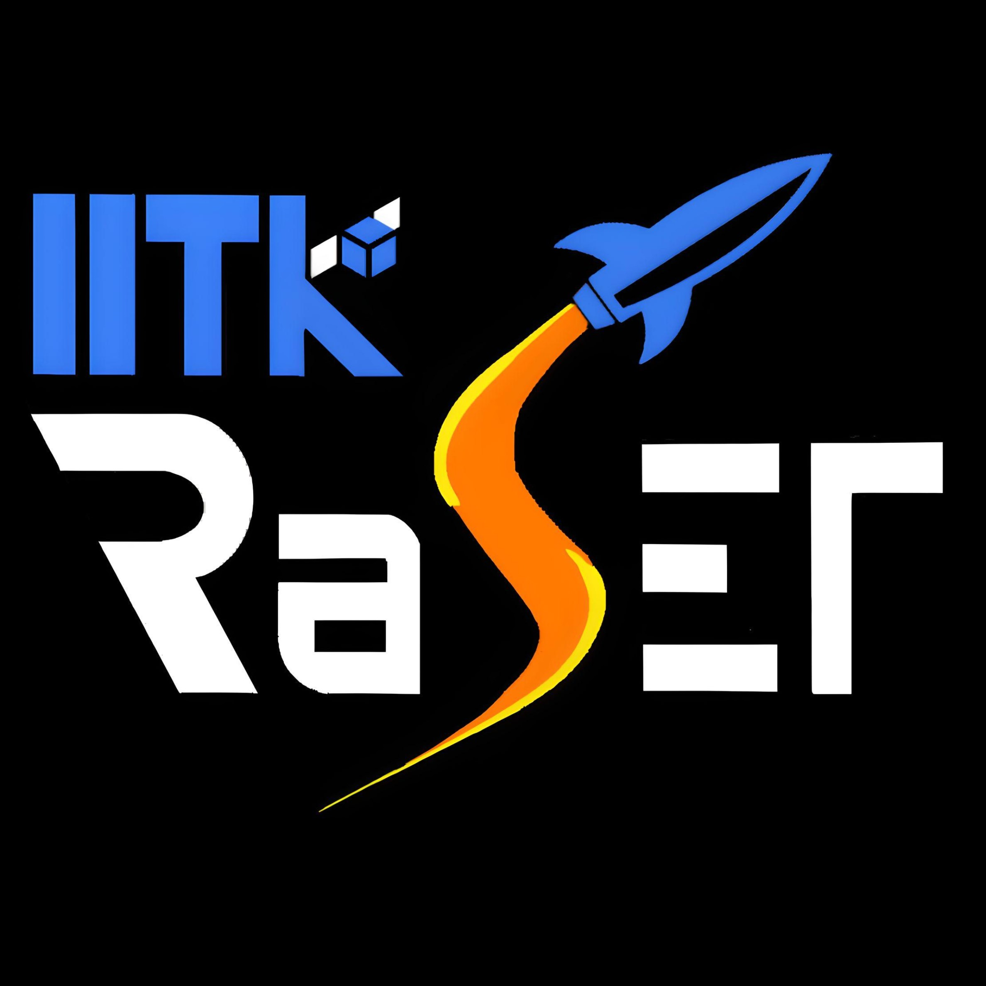

IITK Rocketry and Space Exploration Team



TABLE OF CONTENT

BACKGROUND ..........................................................................  
PROBLEM STATEMENT ............................................................  
SUMMARY OF THE PROJECT ...................................................

OBJECTIVE / PROGRAM GOALS ..............................................  
DELIVERABLES & TIMELINE.......................................................

IMPACT ...................................................................................

CURRENT PROGRESS……………………………………………………………..  
BUDGET ESTIMATE ...................................................................

**BACKGROUND**

IITK RaSET is a group of highly motivated and dedicated students who are passionately driven towards working in the field of experimental rocketry. The aim is to gain hands-on engineering knowledge via complete in-house design, fabrication and launching of custom experimental rockets and to learn from and compete with the best student-rocketry teams around the globe. The team began its journey in August 2022 with 4-5 students brainstorming their ideas and now stands 15+ members strong, supported by several faculty advisors and their respective laboratories.

**PROBLEM STATEMENT**

The project aims to manufacture an experimental sounding rocket for an apogee of 10,000 ft. The team aims to participate in the Spaceport America Cup and represent IIT Kanpur in this international inter-collegiate competition.

**SUMMARY OF THE PROJECT**

The project involves design and manufacture of completely in-house, high-performance rocket body parts made up of glass-fibre composite. It also involves manufacturing of completely student designed solid propellant rocket motor and implementation of a flight computes for in-flight data-logging and parachute ejection.

**OBJECTIVES**

The project goals for different subsystems are as follows:

**Propulsion**

To develop a solid-propellant-rocket-motor from scratch.

To finalise a propulsion system capable of reaching 10,000 ft

**Avionics and Recovery**

To develop a flight computer capable of logging data from various sensors

To incorporate telemetry systems for real-time tracking of the rocket

To test ejection system for Parachute recovery of Rocket and Payload

**Structures**

To implement composite layup manufacturing for custom body parts

To fabricate Rocket nose-cone, body-tube and fins using glass fibre composite

**DELIVERABLE & TIMELINE**

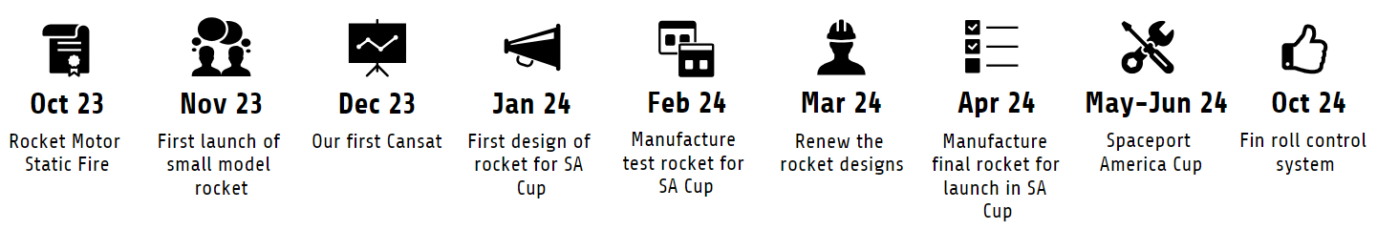

|  |  |
| --- | --- |
| Deliverables | 1. Design, manufacture and static test fire of KNSB based solid rocket motor to validate the experimental results against the simulation.  2. Design, fabrication and launch of a rocket with a COTS F-class motor to validate ejection and recovery systems at ~1000ft apogee.  3. Design and testing of a Cansat and from suitable height to validate sensors, recovery system and the real time telemetry.  4. Design and manufacture of a large-scale rocket with an M-class SRAD motor targeting the 10,000 ft apogee for SA Cup for a test launch.  5. Rebuild a rocket for SA cup 2024 targeting 10,000 ft apogee problem statement with changes to the rocket based on the data acquired from test launch.  6. Develop an active control system for a rocket using fin roll stabilization and test it on a small rocket with COTS E-class motor**.** |
| Project Timeline | **Oct 2023** – First static test fire of solid rocket motor.  **Nov 2023** – First rocket launch to a height of around 1000ft.  **Dec 2023** – Cansat sensor & recovery testing from a suitable height  **Jan 2024** – Completion of first design for SA Cup problem statement.  **Feb 2024** – Manufacturing of all components of the design.  **Mar 2024** – Testing and suitable modifications in the design  **April 2024** – Finalised Ready for Launch.  **May to July 2024** - Spaceport America Cup  **October 2024** - Fin stabilization system will be tested on a small rocket |

**IMPACT** (SOCIAL / SCIENTIFIC)

India's thriving space-tech industry holds a promising future. Our team is dedicated to carrying the legacy of IITK’s JUGNU Nano-sat mission forward, contributing to the Indian space revolution.

Through hands-on projects and competitions our members would be empowered and shaped into versatile engineers. Creating cutting-edge rocketry and payload hardware from scratch will let them implement classroom knowledge to real problem statements.

The team will provide an inclusive platform, welcoming students passionate about space tech, fostering learning, innovation, and intensive project work, regardless of their background/major.

As the team progresses, it’ll incline towards sustainability, reusing components for multiple flights, and exploring eco-friendly propellants and materials and efficient manufacturing methods.

The team is not just about building rockets but building a positive space tech culture for the upcoming batches at IITK, and help them kindle their dream of becoming space scientists and engineers.

**Progress till now...**

**Propulsion Simulation, manufacturing, and test fire**

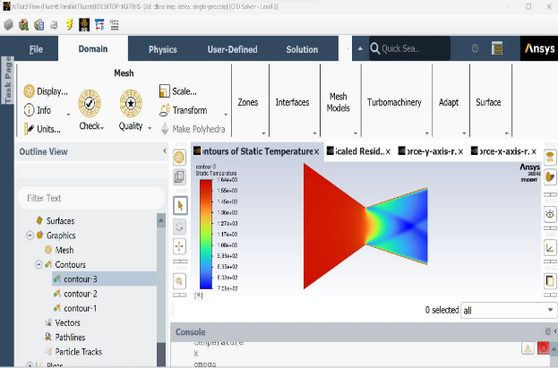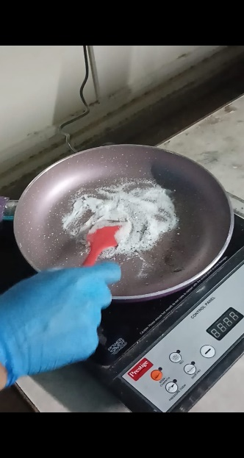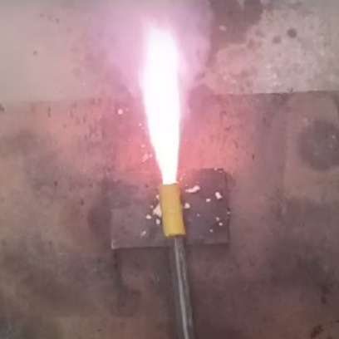

**Glass-Fibre Composite, manufacturing via Hand-Layup and Curing under pressure**

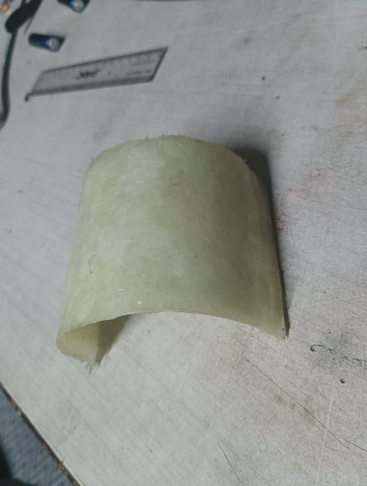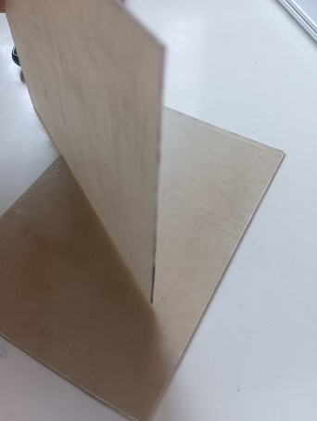

**Flight Computer Testing for real-time data logging, PCB design**

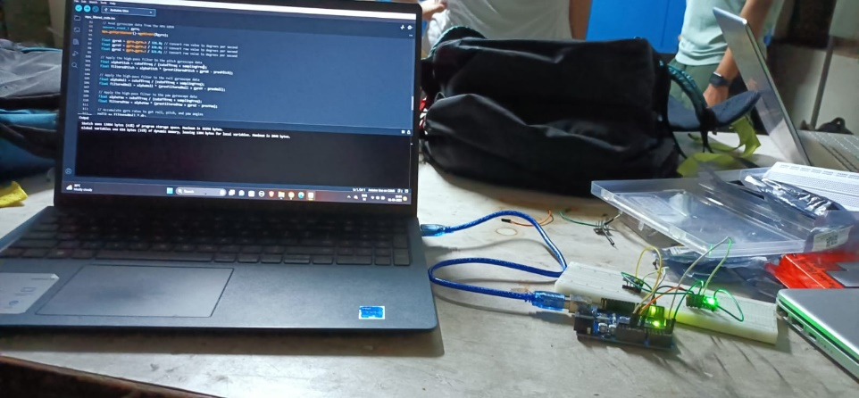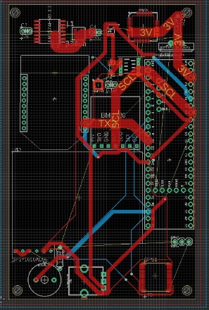

**Team Photo**

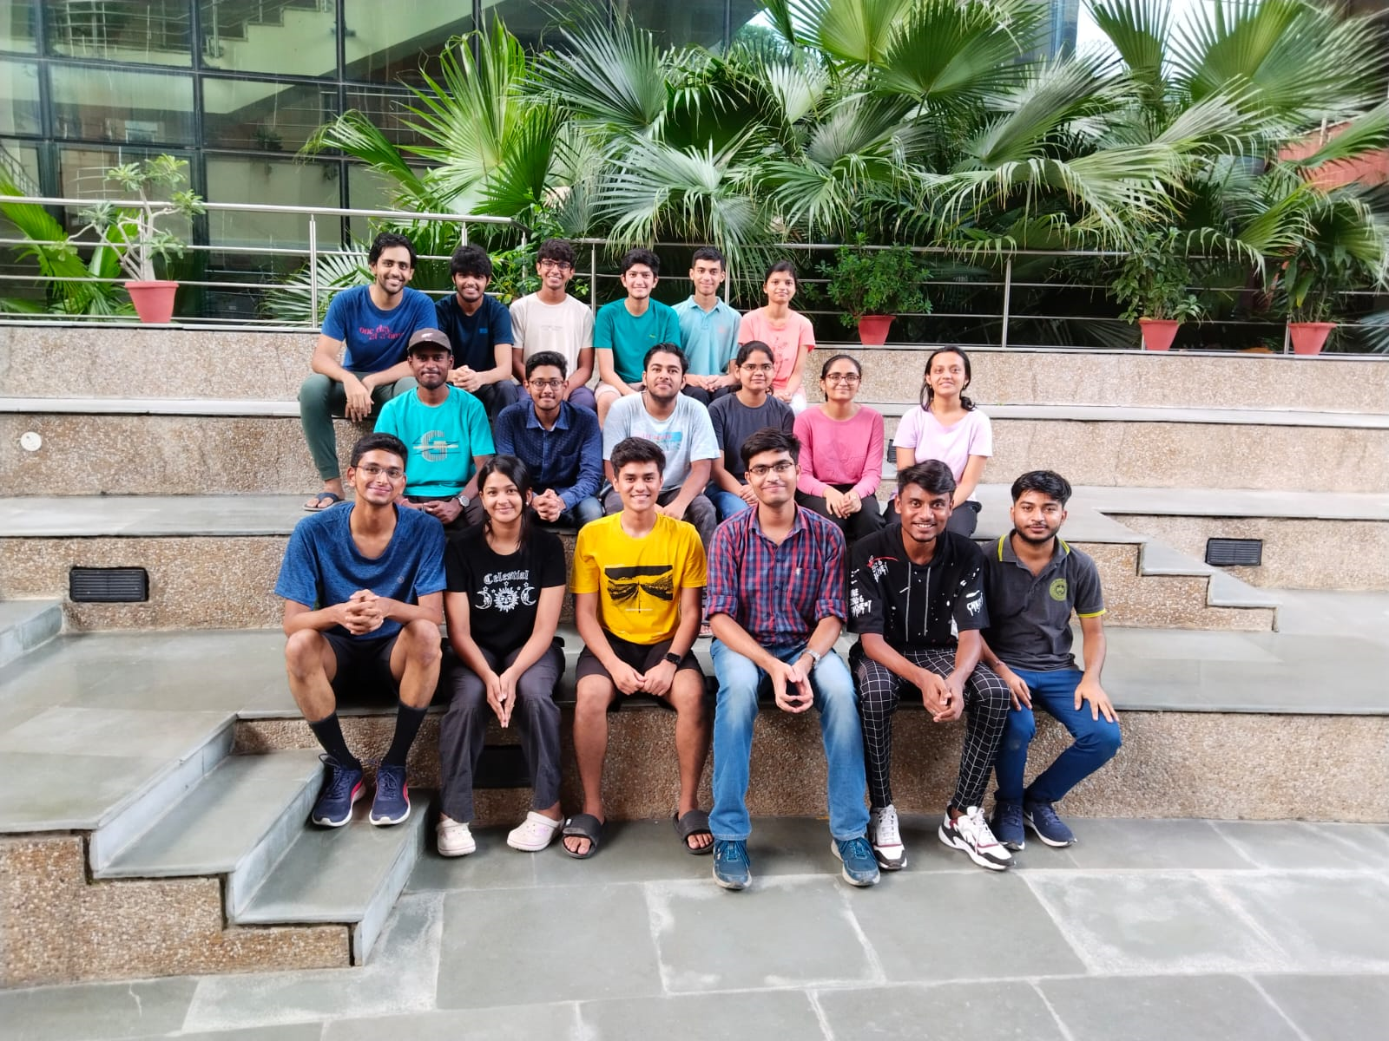

**[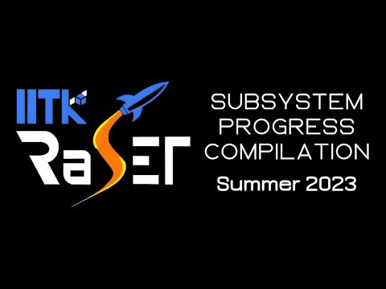](https://www.youtube.com/embed/cpMFYjqqu7E?feature=oembed)**

**YouTube Link:** [**https://youtu.be/cpMFYjqqu7E?feature=shared**](https://youtu.be/cpMFYjqqu7E?feature=shared)

**BUDGET ESTIMATE**

|  |  |  |
| --- | --- | --- |
| **Travel** | Flight Tickets and Sustenance | 15,00,000 |
| **Competition related logistics** | Registration fees | 1,24,000 |
| Flyer of Record | 80,000 |
| **TOTAL** | 2,04,000 |
| **Contingency** | Transportation of goods | 2,50,000 |
| **Consumables** | Fibreglass 2oz, 10yards, 38" (1 roll) | 11,200 |
| Fibreglass 1.5oz, 3 yards, 50" (1 roll) | 7,000 |
| Epoxy & Hardener | 16,500 |
| Parachutes (2) | 14,000 |
| Tender Descender | 5,100 |
| Shock Cords | 6,000 |
| Carabiner | 2,500 |
| Deployment Bag | 4,000 |
| Swivel Hooks | 2,000 |
| Eye Bolts | 2,000 |
| E class motors | 5,250 |
| Motor 10k feet | 72,000 |
| Motor 1k feet | 14,000 |
| RRC3 altimeter | 6,793 |
| GPS (Featherweight) | 38,000 |
| Teensy 4.1 (2 units) | 6,500 |
| XBee Module S2C (2 units) | 4,500 |
| MPU-9250 (5 units) | 4,500 |
| Stock Steel | 30,000 |
| **TOTAL** | 2,40,643 |
| **Non consumables** | Basic Workspace Requirements | 24,000 |
| Equipment and Safety Requirements | 36,000 |
| **TOTAL** | 52,000 |
|  | Project Costs | 22,46,643 |
| **Administrative Charges** (5% of the Project Cost) |  | 1,12,332 |
| **Project Management Cost** (7% of the Project Cost) |  | 1,57,265 |
| **TOTAL** |  | 25,16,240 |